**­­­­­The Laurel Review**

**44691-01/02 GRAD DIRECT PROJECT, Fall 2019**

**Team Ignite**

**Team Members:**

Vijay Kumar Karanam

Ravi Kumar Atluri

Harsha Vardhan Reddy Nallavolu

Manasa Goriparthi

Bhavani Pathuri

Fahreen Mohammad

**Client Name and Affiliation:**

Luke Rolfes

Co-editor of the Laurel Review

Department of Language, Literature

Northwest Missouri State University

**Instructor:**

Dr.Aziz Fellah

Assistant Professor

Department of CSIS

Northwest Missouri State University

**The Laurel Review**

**1. Introduction**

* 1. **Problem Statement**

The Laurel Review is a biannual print magazine with submissions of poetry, fiction, creative nonfiction, script, review, and those that blur the lines between genres. They maintain a website for this, which the clients feel outdated and wants a fresh look. The older website has multiple problems the major among those were they need a complete UI change of the current website and wanted us to add chapbooks and podcasts to the current website. We as a team working on all the requirements to update the website and fix all the existing issues and add additional working functionalities.

**2. General Description**

**2.1 Product Perspective**

We are developing a better User Interface for the Laurel Review team to interact with the application. As of now they are using the basic templates to view their screen. With advanced responsive design technologies, the application will look good. Also, we changed the process of creating new issue. We are trying relief client for enter each and everything while creating a new issue like, title, content, author, author description and content description etc., by just uploading a file containing everything.

**2.2 Product Functionality**

As our project is upgrading an existing application, most of the functionalities remains same. In addition to the existing functionalities we are implementing chapbooks, podcasts, notifications and social website news feed. The main functionality of the application is to create issue, update issue and delete issue if needed. Second is adding author information to the respective work he did on the issue. Subscriptions and submissions of issues also play a main role in the application interaction.

**2.3 User Characteristics**

There are two main type of users for this application. One is admin and other all are general users. Only admin will have login credentials to create, update or delete content on website and general users can normally use the application, if they want to submit or subscribe to an issue, the application will direct to third party website where they can pay as they go. Admin tasks are like creating a new issue, updating notifications on home page, updating issue so that all contents can be seen by users, deleting issue if it outdated.

**2.4 General Constraints & Restrictions**

The only constraint about this application is the admin should use a template while creating an issue, because it is hard to get the data from a normal issue as pdf, so we planned to give a template to client, so that while creating a new issue he uses this template as reference and create the issue.

**2.5 Assumptions and Dependencies**

There are some dependencies for this application. The writer has to subscribe to the application to submit his work, unless he can’t able to submit. For payments and subscriptions, the application depends on third party website.

**3. Specification of Requirements**

**3.1 External Interface Requirements**

**3.1.1 User Interfaces**

This is the main requirement of client. They wanted us to change the look and feel of the website. On opening their application, on home page, they asked for social media feed like Facebook which we have implemented. On the navigation bar, they proposed to have two options for chapbooks and podcasts. The main objective is the overall application should be responsive and look good for the user who all using the application.

**3.1.2 Hardware Interfaces**

            There are no any additional hardware requirements for this application. As the application is hosted eleven2.com, they maintain the server and database. The only hardware requirement is anyone having desktop or tab or laptop with an internet connection can use this application.

**3.1.3 Software Interfaces**

For responsive design of the application we are using, Bootstrap, HTML and CSS as front end technologies. For backend to interact with database we are using PHP. While developing the application in local, we are using XAMPP which uses APACHE server to start the application server in local. For editing code we are using Visual Studio Code.

**3.1.4 Communication Interfaces**

            There are two main parts how user communicates with client. For Subscription and Submission, user uses the third party page or else to directly communicate with client users can use mail id provided on about us page.

**3.2 Functional Requirements**

**3.2. List of Requirements with description**

**1. Complete User Interface Change:** This is the main requirement of client. They wanted us to change the look and feel of the website. On opening their application, on home page, they asked for social media feed like Facebook which we have implemented.

**2. Issue Uploading:** While uploading an issue, client asked to remove the mundane work they are currently doing. So we planned to create a pdf file which they can use to create an issue.

**3. Social Media Feed:** On opening their application, on home page, they asked for social media feed like Facebook which we have implemented.

**4. Navigation Bar Options:** As of now there are no options for Chapbooks and Podcasts on their application navigation bar, so they asked to implement these two options.

**5. Notifications:** Client asked to create a field of list view that displays latest news information related to website.

**6. Author Description:** Whenever the user clicks on author name, a pop up should display with author description along with headshots.

**3.3 Non-Functional Requirements** (Include that are relevant to your project)

**3.3.1 Performance:** The responsive time of the application is very good. As application is hosted on eleven2.com and also includes moderate functions, the applications response very quickly.

**3.3.2 Reliability:** The application performs all the required functions in a specified time without any delays unless it is a network issue.

**3.3.3 Availability:** The website is already hosted in eleven2.com, so the application is always up and running without any issues.

**3.3.4 Maintainability:** Theapplication is maintained by Laurel Review Team. If there are any issues admin will take care of it.

**3.3.5 Portability:** Aswe designed this applications as responsive, so if we open the application in tab or mobile or laptop, the view is automatically adjusted. Also the application can be open on any system, with any type of Operating System having internet access.

**3.4 Database Schema:**

We have created the database tables and relation as follow:

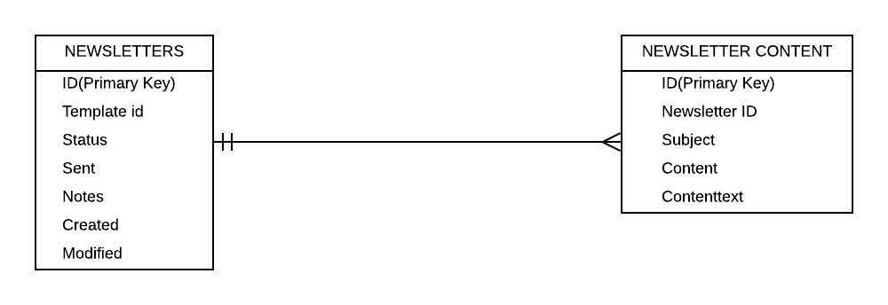

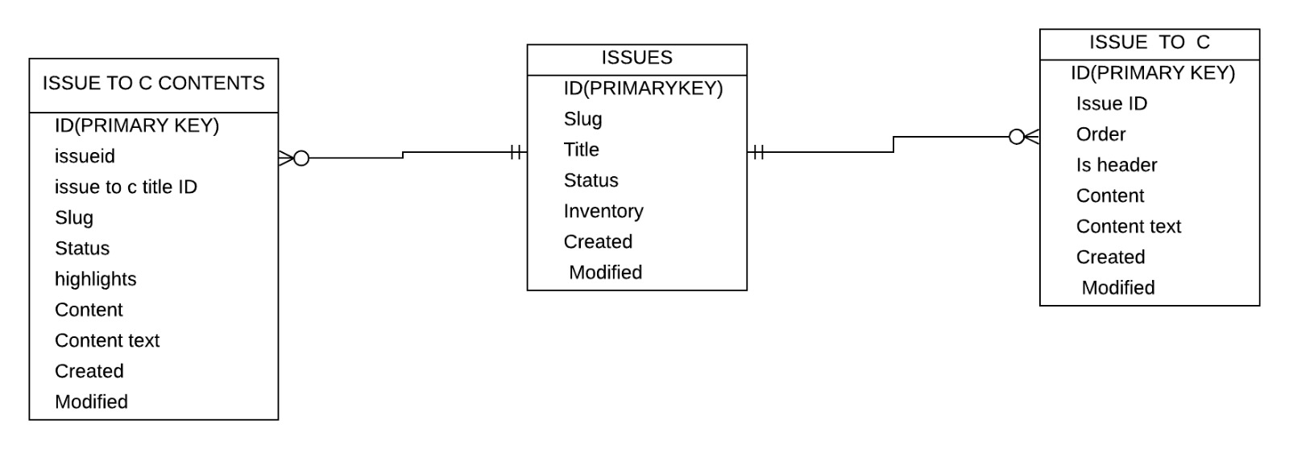

**4. Software Architecture:**

**4.1 Component Diagram:**

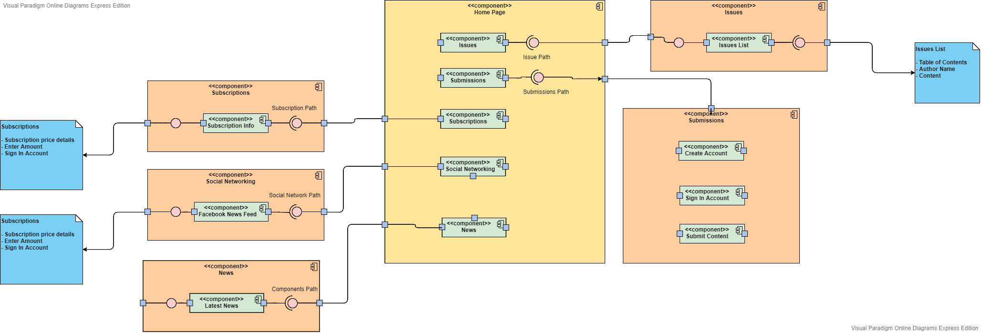

**4.2 Sequence Diagram:**

**Issues-Admin:**

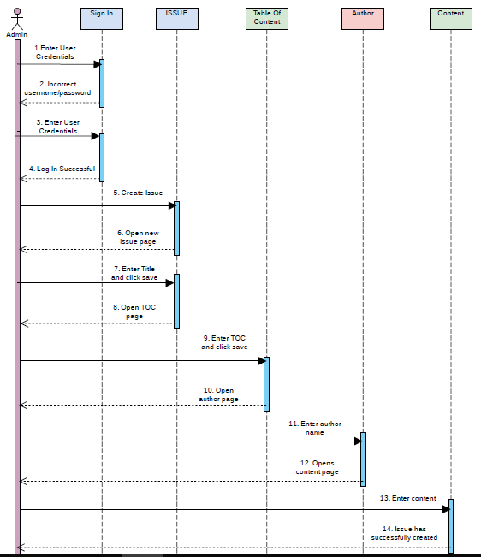

**Issues – User:**

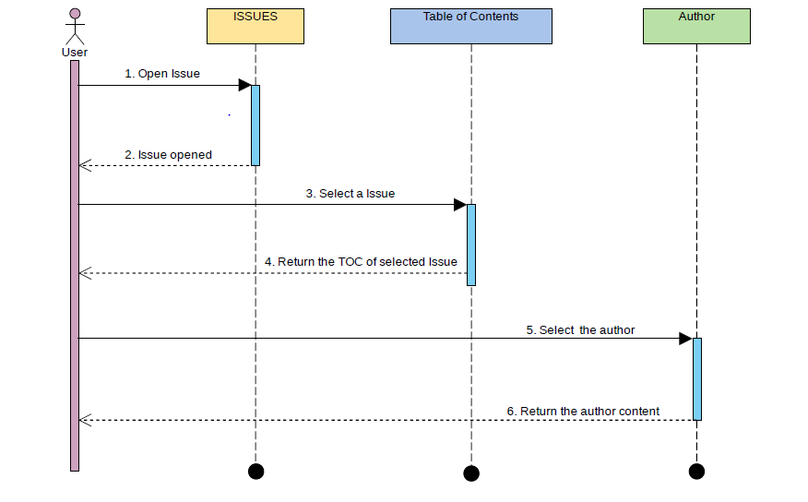

**Subscription:**

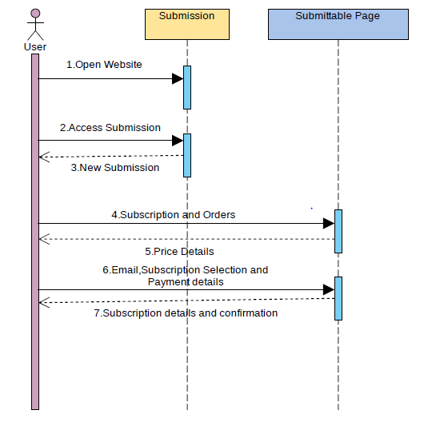

**Submission:**

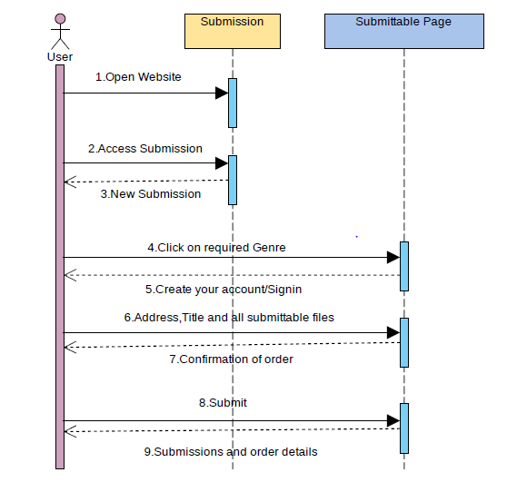

**News:**

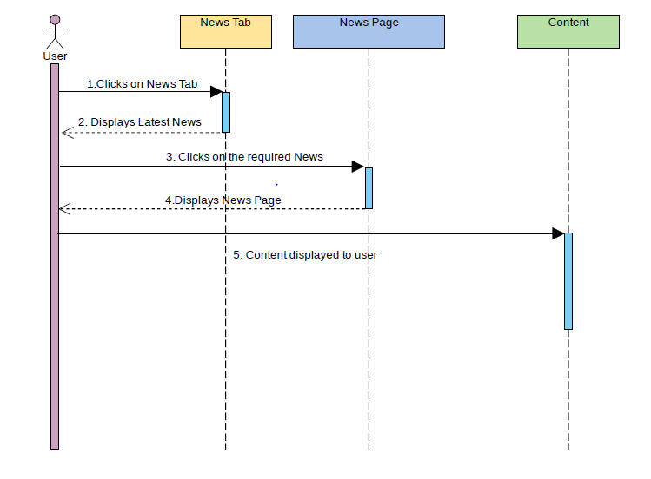

**5. Design**

**5.1 Introduction:**

We have created basic design with requirements provided by the client.

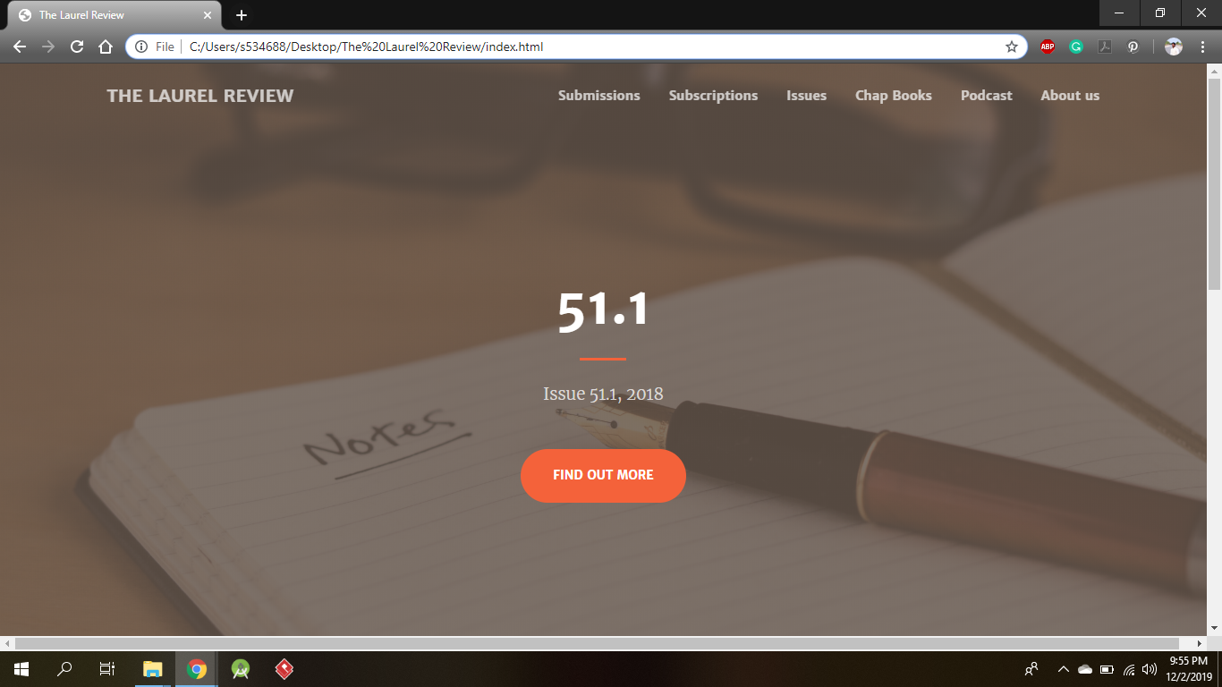

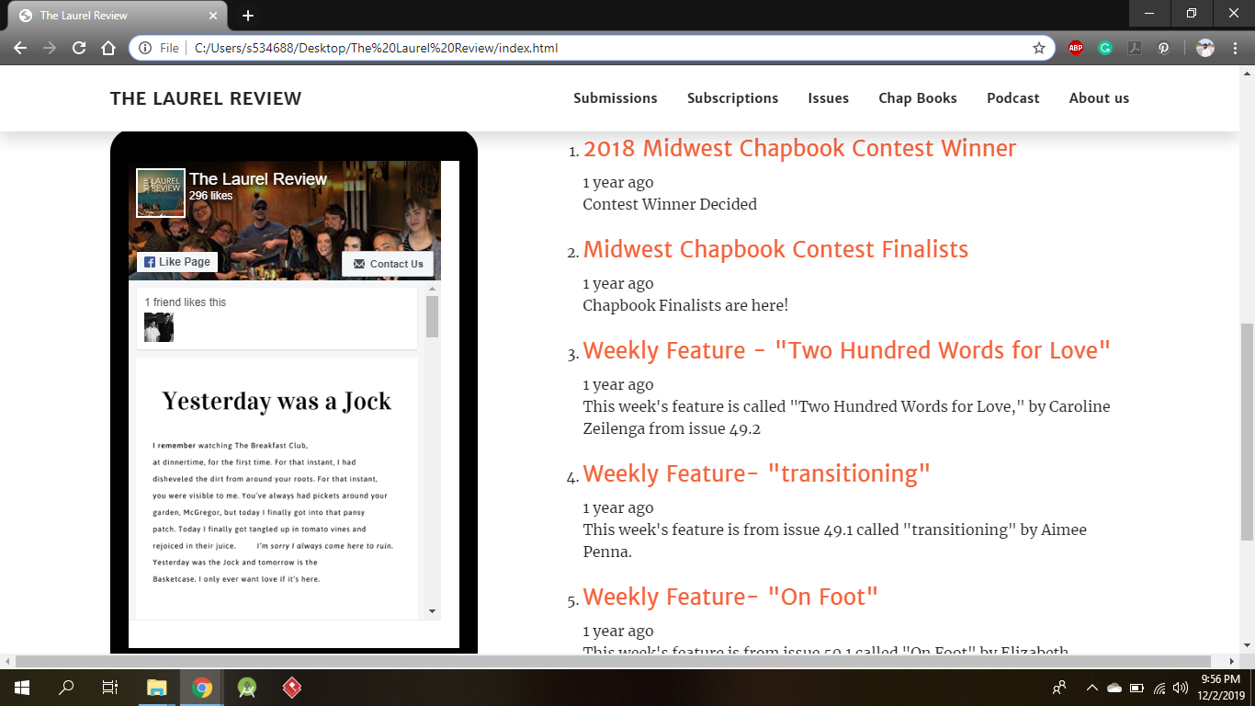

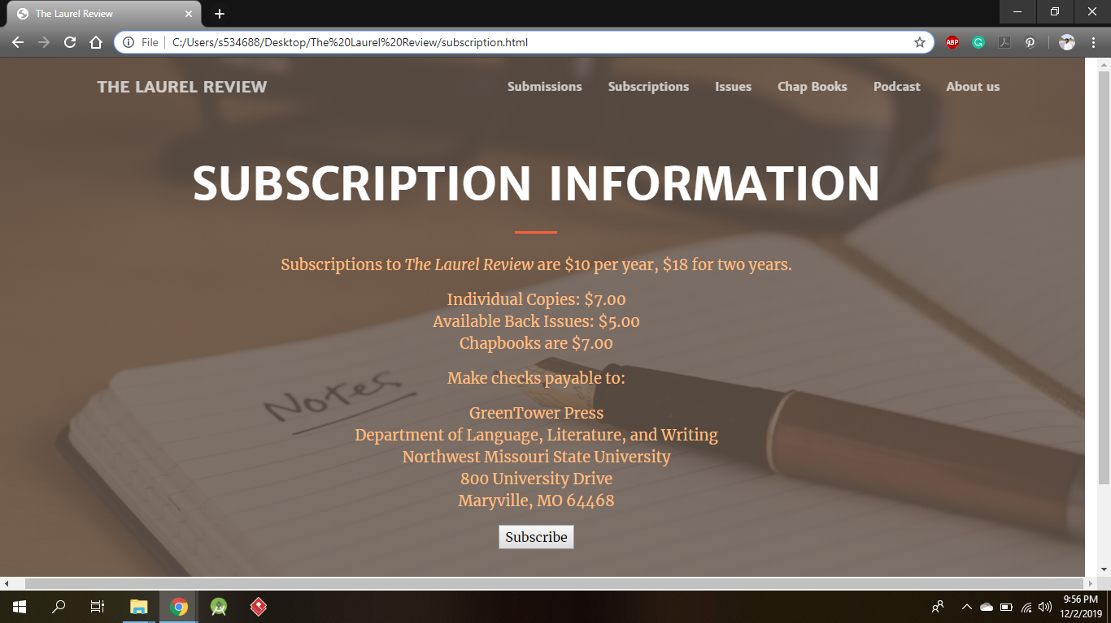

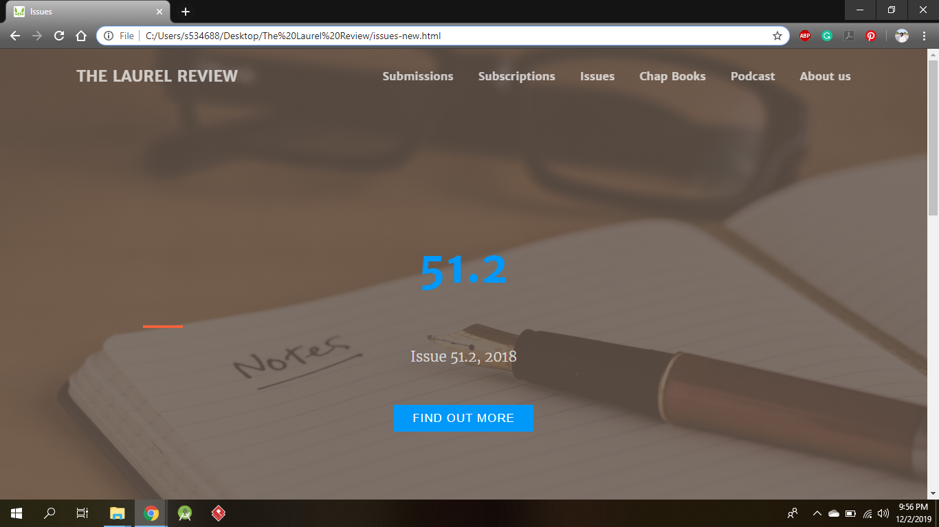

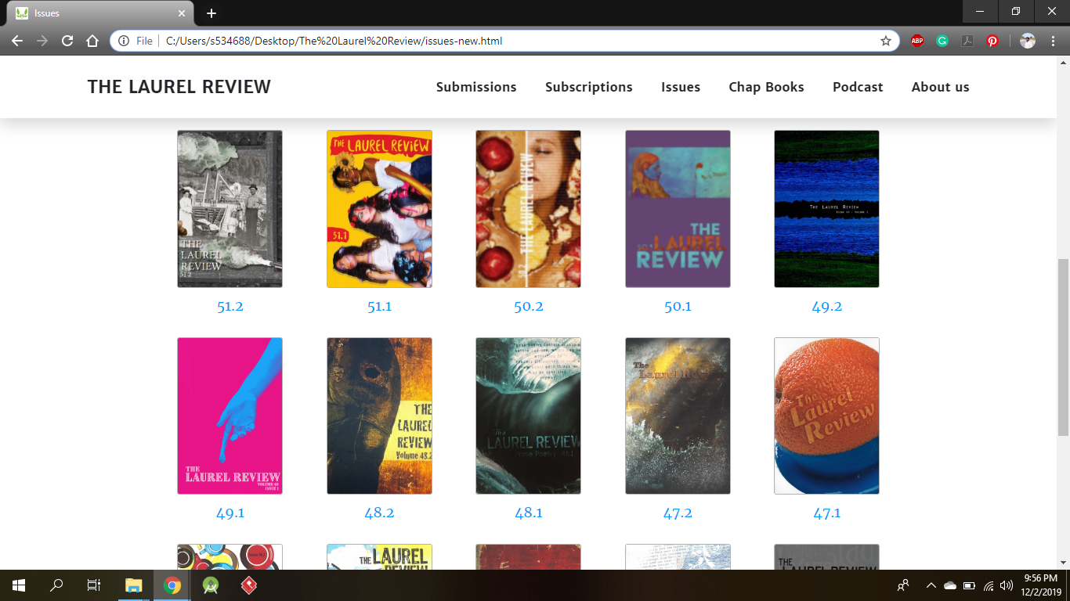

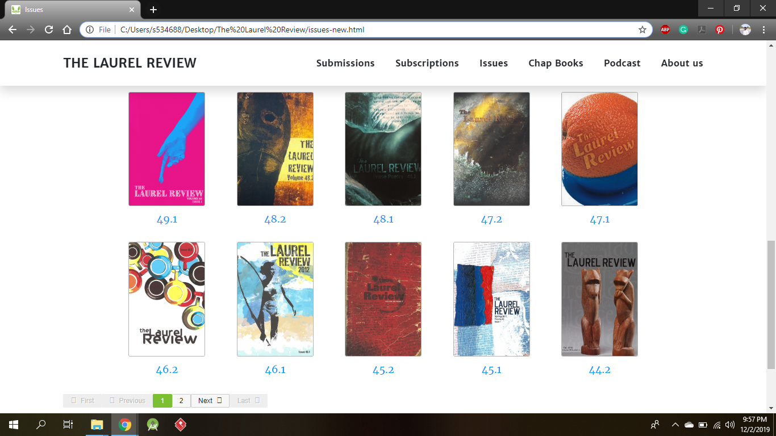

**5.2 UML Description:**

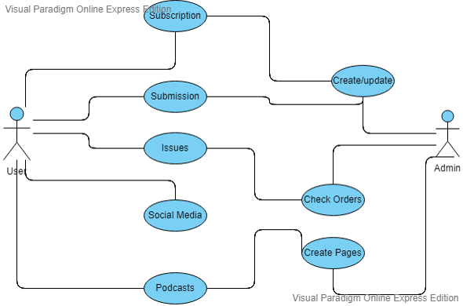

**5.3 Module Design and Organization:**

1. Admin will create new issue.

2. Admin will publish all contents in the issue.

3. Admin will post notifications regarding the application.

4. User can read all issues those published by admin.

5. User can submit his work for a new issue.

6. User can subscribe to new issue for hard copy.

7. User can see new notifications published in website.

8. User can see client Facebook Timeline on home page.

**6. Client Feedback**

So far client is quite impressed and satisfied by our work. If they require anything to be improved by us will get to know on weekly client meeting and will update it according to the requirements and take the grant for the development in the upcoming week. So it’s a smooth and friendly process running between us and the client.

**7. Contribution for Documentation**

**1. Introduction** – Vijay Kumar Karanam and Harsha Vardhan Reddy Nallavolu workd on Introduction.

**2. General Description** - Ravi Kumar Atluri and Harsha Vardhan Reddy Nallavolu woked on General Description and in this Product Perspective, Product Functionality, User Characteristics done by Ravi Kumar and General Constraints and assumptions and Dependencies done by Harsha.

**3. Specification of Requirements –** In This module, User, Hardware and Software Interfaces are done by Fahreen Mohammad and Communication Interfaces and Functional Requirements are done by Manasa Goriparthi.

**4. Non-Functional Requirements** – In this module Performance, Reliability and Availability are done by Bhavani Pathuri and Maintainability and Portability are done by Manasa Goriparthi.

**5. Software Architecture:** In this module Component Diagram done by Vijay Kumar Karanam and Sequence Diagram done by Ravi Kumar Atluri.

**6. Design:** In this module, Introduction done Fahreen Mohammad and UML Description and Module Design and Organization done Bhavani Pathuri